**Light pollution - Man of many faces:** *"I see you.."*

Inspired by George Orwell's book 1984, the concept of "Big Brother is watching over you" is portrayed through the digital prints on the wall and the mapped projections of my own footage/animations syphoned through VDMX.

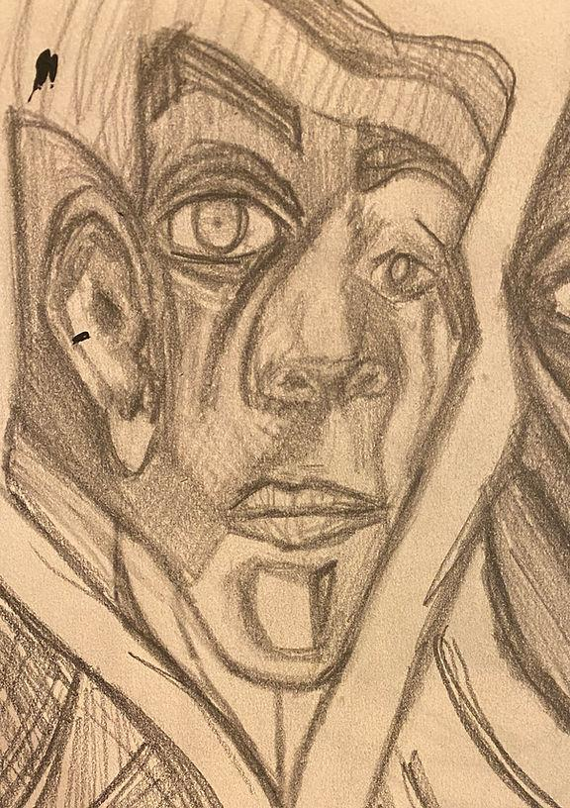

The idea surrounding thought crime and the increased presence of government surveillance through the collection of mass data from social media have made the story and notions by George Orwell seemingly more relevant in today's society. By incorporating the growth of technology by adding elements of animation combined with abstract portraiture, which is emphasized through the use of VDMX to increase the pixelation and glitches in images present in technology, the series of pieces portray Big Brother watching over you, the man of many faces seeing you.

**Big Brother;** portrays the face of a hierarchical power figure who controls the media outlets and blurs away those who do not fit or suit his beliefs, shown through the mapped projection of the animation of pixels blurring the lines of the image to hide the truth within the media while also including resize glitch visual effect from VDMX to incorporate movement to the figure, bringing him to life. The bold red color of the image represents the power and dominance of the face. Overlayed on the animation was a video I created with LED lights. Then, using VDMX, I added effects such as fast mosh, color blowout, and kaleidoscope to develop a trippy visual that provided more contrast and movement.

**Blurry Lines;** conveys the misinformation in the media and how facts can be misrepresented and falsified to the point where society struggles to find the truth. The moving lines in the animation blur into multiple faces, showing various stories behind one, leading to misinformation and factual representation in media. Incorporating VDMX into the mapped projection, I combined the pinch distortion effect and a pixel glitch effect, providing a more smooth portal effect to where the face is engulfing you but also incorporating the notions in "1984" of the broken television screen.

**Blink;** displays the fast and continuous flow of news coming through our lives as we blink and miss the truth behind new outlets. The animation's color blending motion and fading in of the blinking face represents this quick news flow in society which was enriched with the VDMX effect Chroma Zoom and fast mosh glitch to enhance the blinking of the animation. Furthermore, the bright multicolor gradient background combines all signifying powers present, representing inclusivity and diversity that social movements aim to combat.